**Task4:**

CODE

#include<stdio.h>

#include<conio.h>

void main (void){

int a,b;

printf("Enter two numbers=\n");

scanf("%d %d",&a,&b);

for (int i=a; i<=b; i++){

if(i>=1 && i<=9){

switch(i){

case 0:

printf("Zero\n");

break;

case 1:

printf("One\n");

break;

case 2:

printf("Two\n");

break;

case 3:

printf("Three\n");

break;

case 4:

printf("Four\n");

break;

case 5:

printf("Five\n");

break;

case 6:

printf("Six\n");

break;

case 7:

printf("Seven\n");

break;

case 8:

printf("Eight\n");

break;

case 9:

printf("Nine\n");

break;

}

}

else if(i>9){

if(i%2==0){

printf("EVEN\n");

}

else if(i%2!=0){

printf("ODD\n");

}

}

}

}

OUTPUT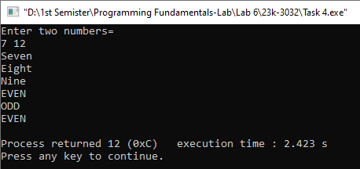

**Task5:**

CODE

#include<stdio.h>

#include<conio.h>

void main (void){

for (int i=0; i<=6; i++){

if(i%2==0){

printf("%d\t%d\t%d\t%d\n",i,i,i,i);

}

if(i%2!=0){

printf("\t%d\t%d\n",i,i);

}

}

}

OUTPUT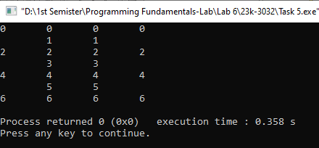

**Task6:**

CODE

#include<stdio.h>

#include<conio.h>

void main (void){

int total,userpick,computerpick;

total=21; userpick=computerpick=0;

printf("The total matchsticks are 21\n\n");

while (1){

printf("\nPlease pick 1,2,3 or 4 matchsticks");

scanf("%d",&userpick);

total=total-userpick;

printf("\nThe remaining matchsticks are %d",total);

computerpick=5-userpick;

printf("\nThe remaining match sticks are %d",total-computerpick);

total=total-computerpick;

if (total==1){

printf("\nYou Lost\n");

break;

}

}

}

OUTPUT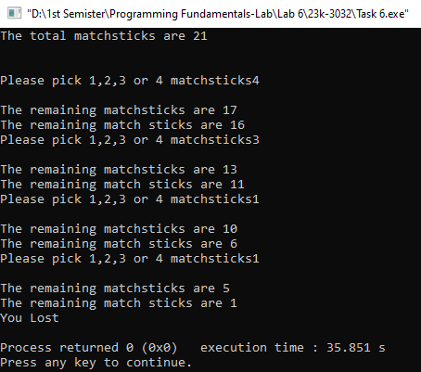

**Task7:**

CODE

#include<stdio.h>

#include<conio.h>

void main (void){

int numbers[100];

int size,sum;

size=sum=0;

printf("Please enter the size of the array you want\n");

scanf("%d",&size);

printf("Now enter the number you want\n");

for(int i=0; i<size ;i++){

scanf("%d",&numbers[i]);

}

for (int i=0; i<=size ;i++){

sum=sum+i;

}

printf("The sum of the entered numbers is %d",sum);

}

OUTPUT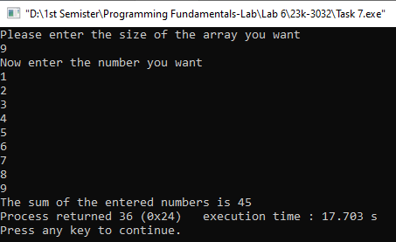

**Task8:**

CODE

#include<stdio.h>

#include<conio.h>

void main (void){

int size, numbers[100];

printf("Please enter the size of the array\n");

scanf("%d",&size);

printf("Now enter the numbers\n");

for(int i=0; i<size; i++){

scanf("%d",&numbers[i]);

}

for (int i=size-1; i>=0 ;i--){

printf("\n%d",numbers[i]);

}

}

OUTPUT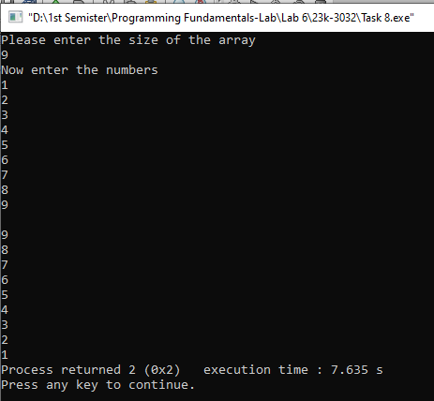

**Task9:**

CODE

#include<stdio.h>

#include<conio.h>

void main (void){

int numbers[]={4,1,6,8,10,21,8,9,2,6};

int maximum,minimum;

maximum=numbers[0];

minimum=numbers[0];

for (int i=0; i<10; i++){

if (minimum>numbers[i])

minimum=numbers[i];

if (maximum<numbers[i])

maximum=numbers[i];

}

printf("The maximum number is %d\n",maximum);

printf("The minimum number is %d\n",minimum);

}

OUTPUT